MIS SAP ID AND SIID UPDATES

Clarify case# 5003719-1

Change MISMRGEA90216069 to 460175P in the SIID field.

Using 5003719,

Clarify case# 5016010-1

Change MISMRGRA90216120 to 460176P in the SIID field.

THE RELEVANT SQL Query

UPDATE SIID

(USED TO VERIFY CONTENTS OF OBJID FIELD…)

select SIID from table_sof where objid =

(select case2sof from table_case where id_number = '4105194')

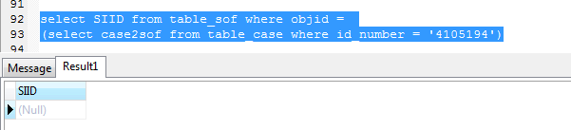

update table_sof set SIID = '463084P' where objid =

(select case2sof from table_case where id_number = '4105194')